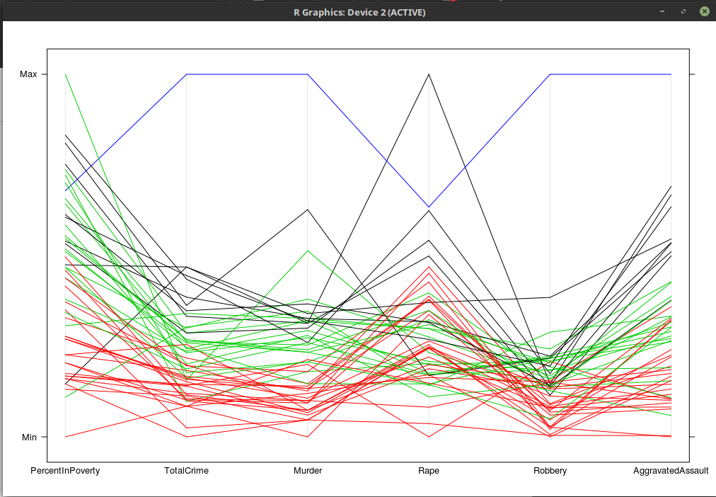
I used K-Means Cluster Analysis to find 4 clusters. As you can see from the clusters, states that have low poverty tend to have low crime rates. The singular blue line at the top is Washington DC, which according to the data has obscenely high crime rates. It should probably be excluded as an outlier. It also appears that areas with extremely low or extremely high poverty levels have more rape crimes than areas with medium poverty.

